**Laboratory Report Cover Sheet**

|  |
| --- |
| SRM INSTITUTE OF SCIENCE AND TECHNOLOGY  Faculty of Engineering and Technology  Department of Electronics and Communication Engineering |
| **18ECO108J- EMBEDDED SYSTEM DESIGN USING ARDUINO**  **VI Semester, 2020-2021 (Even Semester)** |

**Title of Mini Project : Traffic Light Controller (4-way)**

**Date of Submission :23rd October, 2021**

|  |  |  |  |  |
| --- | --- | --- | --- | --- |
| **Particulars** | **Max. Marks** |  | **Marks Obtained** | |
|  |  | **Name: Richa Gupta** | **Name: Parth Moghekar** | **Name: Hamad Syed Andrabi** |
|  |  | **Register No.:**  RA1911003010357 | **Register No.:**  RA1911003010368 | **Register No.:**  RA1911003010395 |
| Design, Code | 25 |  |  |  |
| Demo verification &viva | 10 |  |  |  |
| Project Report | 05 |  |  |  |
| **Total** | **40** |  |  |  |

**REPORT VERIFICATION**

**Staff Name : Signature :**

**Objective:**

Roads without any supervision or guidance can lead to traffic conflicts and accidents. Traffic signals are required for an orderly flow of traffic. A traffic signal is used as an instructing device that indicates the road user to act as per the displayed sign.

Traffic lights allow everyone to cross the intersection point one by one, reducing conflicts between vehicles entering intersection points from different directions. It provides road safety, also helps to solve traffic in simple manners.

There are different colours in traffic lights. Each light has a meaning, and these lights tell drivers what to do.

* Red light ON- A driver should stop.
* Yellow light ON- A driver has to slow down and be ready to stop.
* Greenlight ON- A driver can start driving or keep driving.

**Software Detail:**

* [Arduino Uno](https://robu.in/product/arduino-uno-r3/)
* [Breadboard](https://robu.in/product/transparent-830-points-solderless-breadboard/)
* [LEDs ( Red, Yellow, Green)](https://robu.in/product/5mm-led-diode-light-assorted-kit-diy-leds-set-red-white-yellow-green-blue-including-red-20pcs-white-20pcs-yellow-20pcs-green-20pcs-blue-20pcs/)
* [Resistor( 220 Ohm)](https://robu.in/product/220-ohm-resistor-1w-metal-film-pack-of-40/)
* [Dupont cables.](https://robu.in/product/male-to-female-jumper-wires-40-pcs-10cm/)

**Abstract /Introduction:**

This project is done to give you an idea of how the traffic light controller works. This is not the real time traffic light controller.

So at start, green light of signal 1 and red lights at other signals will light up to give time to the vehicles at signal 1 to pass.

After 5 seconds, the yellow light at signal 1 will light up to give an indication that the red light at signal 1 is about to come up and also to give an indication to the vehicles at signal 2 that the green light is about to light up.

So after 2 seconds, red light at signal 1 will come up and green light at signal will come up meaning vehicles at signal 1 must stop and vehicles at signal 2 can move.

Similarly the traffic light controller will work for the signal 3, signal 4 and the system will keep looping.

**Block Diagram**

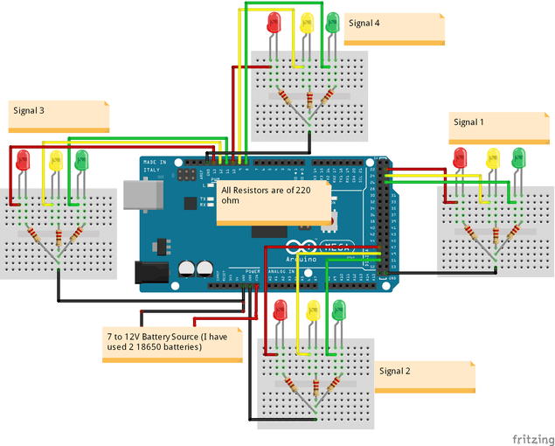

**Code:**

//First of all, we define the pins where we have //connected the LEDs.

int red_1=13;

int orange_1=12;

int green_1=11;

int red_2=10;

int orange_2=9;

int green_2=8;

int red_3=7;

int orange_3=6;

int green_3=5;

int red_4=4;

int orange_4=3;

int green_4=2;

void direction_1_green(void)//green LED of direction 1 will turn ON

{ digitalWrite(red_1,LOW);

digitalWrite(orange_1,LOW);

digitalWrite(green_1,HIGH);

digitalWrite(red_2,HIGH);

digitalWrite(orange_2,LOW);

digitalWrite(green_2,LOW);

digitalWrite(red_3,HIGH);

digitalWrite(orange_3,LOW);

digitalWrite(green_3,LOW);

digitalWrite(red_4,HIGH);

digitalWrite(orange_4,LOW);

digitalWrite(green_4,LOW);

}

void direction_1_orange(void)//orange LED of direction 1 will turn ON

{ digitalWrite(red_1,LOW);

digitalWrite(orange_1,HIGH);

digitalWrite(green_1,LOW);

digitalWrite(red_2,HIGH);

digitalWrite(orange_2,LOW);

digitalWrite(green_2,LOW);

digitalWrite(red_3,HIGH);

digitalWrite(orange_3,LOW);

digitalWrite(green_3,LOW);

digitalWrite(red_4,HIGH);

digitalWrite(orange_4,LOW);

digitalWrite(green_4,LOW);

}

void direction_2_green(void)//green LED of direction 2 will turn ON

{ digitalWrite(red_1,HIGH);

digitalWrite(orange_1,LOW);

digitalWrite(green_1,LOW);

digitalWrite(red_2,LOW);

digitalWrite(orange_2,LOW);

digitalWrite(green_2,HIGH);

digitalWrite(red_3,HIGH);

digitalWrite(orange_3,LOW);

digitalWrite(green_3,LOW);

digitalWrite(red_4,HIGH);

digitalWrite(orange_4,LOW);

digitalWrite(green_4,LOW);

}

void direction_2_orange(void)//orange LED of direction 2 will turn ON

{ digitalWrite(red_1,HIGH);

digitalWrite(orange_1,LOW);

digitalWrite(green_1,LOW);

digitalWrite(red_2,LOW);

digitalWrite(orange_2,HIGH);

digitalWrite(green_2,LOW);

digitalWrite(red_3,HIGH);

digitalWrite(orange_3,LOW);

digitalWrite(green_3,LOW);

digitalWrite(red_4,HIGH);

digitalWrite(orange_4,LOW);

digitalWrite(green_4,LOW);

}

void direction_3_green(void)//green LED of direction 3 will turn ON

{ digitalWrite(red_1,HIGH);

digitalWrite(orange_1,LOW);

digitalWrite(green_1,LOW);

digitalWrite(red_2,HIGH);

digitalWrite(orange_2,LOW);

digitalWrite(green_2,LOW);

digitalWrite(red_3,LOW);

digitalWrite(orange_3,LOW);

digitalWrite(green_3,HIGH);

digitalWrite(red_4,HIGH);

digitalWrite(orange_4,LOW);

digitalWrite(green_4,LOW);

}

void direction_3_orange(void)//orange LED of direction 3 will turn ON

{ digitalWrite(red_1,HIGH);

digitalWrite(orange_1,LOW);

digitalWrite(green_1,LOW);

digitalWrite(red_2,HIGH);

digitalWrite(orange_2,LOW);

digitalWrite(green_2,LOW);

digitalWrite(red_3,LOW);

digitalWrite(orange_3,HIGH);

digitalWrite(green_3,LOW);

digitalWrite(red_4,HIGH);

digitalWrite(orange_4,LOW);

digitalWrite(green_4,LOW);

}

void direction_4_green(void)//green LED of direction 4 will turn ON

{ digitalWrite(red_1,HIGH);

digitalWrite(orange_1,LOW);

digitalWrite(green_1,LOW);

digitalWrite(red_2,HIGH);

digitalWrite(orange_2,LOW);

digitalWrite(green_2,LOW);

digitalWrite(red_3,HIGH);

digitalWrite(orange_3,LOW);

digitalWrite(green_3,LOW);

digitalWrite(red_4,LOW);

digitalWrite(orange_4,LOW);

digitalWrite(green_4,HIGH);

}

void direction_4_orange(void)//orange LED of direction 4 will turn ON

{ digitalWrite(red_1,HIGH);

digitalWrite(orange_1,LOW);

digitalWrite(green_1,LOW);

digitalWrite(red_2,HIGH);

digitalWrite(orange_2,LOW);

digitalWrite(green_2,LOW);

digitalWrite(red_3,HIGH);

digitalWrite(orange_3,LOW);

digitalWrite(green_3,LOW);

digitalWrite(red_4,LOW);

digitalWrite(orange_4,HIGH);

digitalWrite(green_4,LOW);

}

void setup() { // Declaring all the LED's as output

for(int i=2;i<=13;i++) pinMode(i,OUTPUT);

}

void loop() //In the loop function, we controlled the signal one // by one to control the flow of traffic.

{ direction_1_green();

delay(5000);

direction_2_orange();

delay(3000);

direction_2_green();

delay(5000);

direction_3_orange();

delay(3000);

direction_3_green();

delay(5000);

direction_4_orange();

delay(3000);

direction_4_green();

delay(5000);

direction_1_orange();

delay(3000);

}

**Simulation Result:**

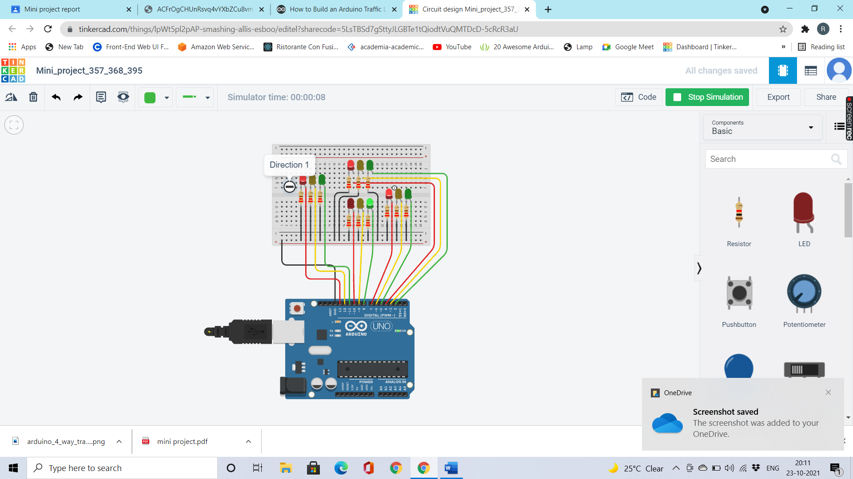

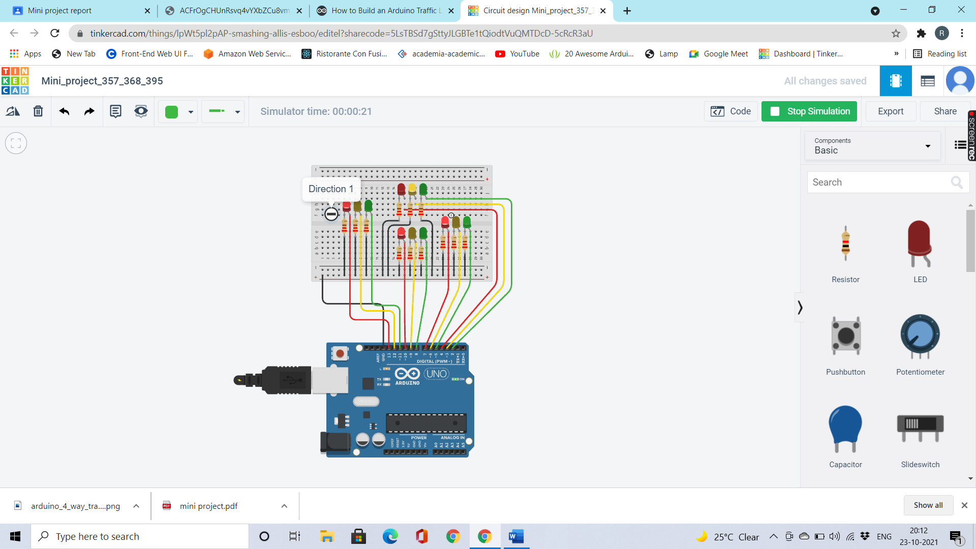

**Conclusion:**

Hence the connection for traffic light controller was established successfully.